ISAD251 Application Design Document

**URLS for repository, web pages**

Repository: <https://github.com/adamli8285/PubProject>

Web Pages: http://localhost:50036/ (local Host)

**Story board**

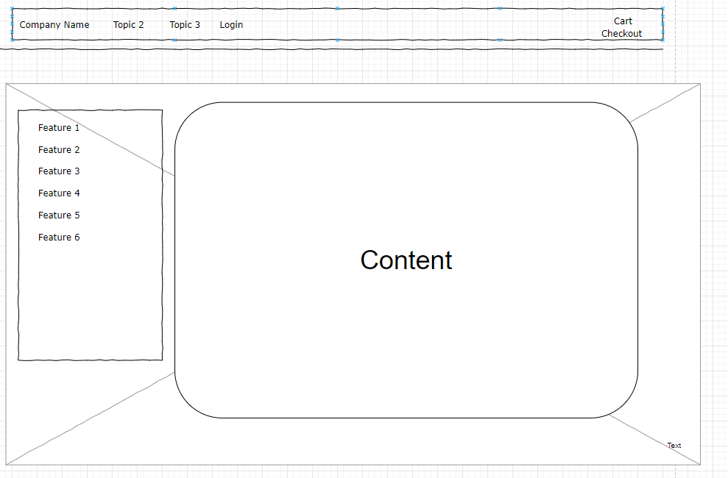

1. user can login at the home page by clicking the login button
2. shopping cart and the checkout function will be at the top right corner
3. feature will be shown at the left side of the website
4. the rest of the website area will be the content area.

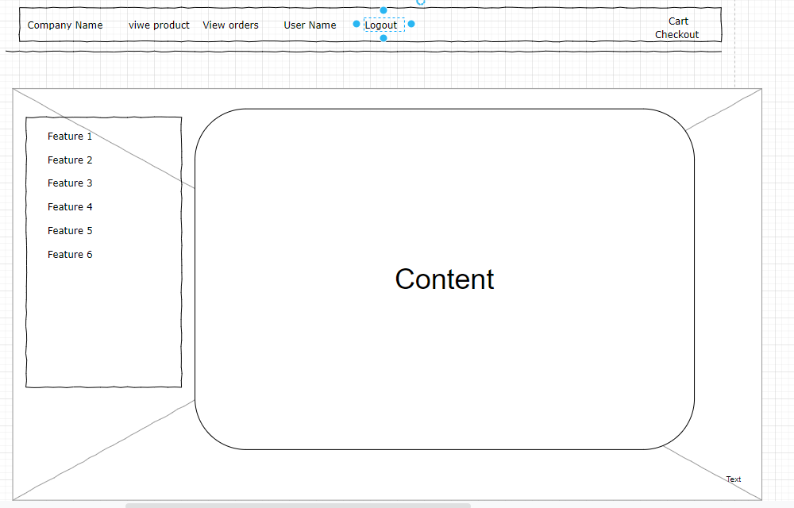

**1. Login button will be changed to “logout” after logged in**

**2. user can view product after signed in**

**3. User can view their orders after signed in**

**4. User can view their profiles after signed in**

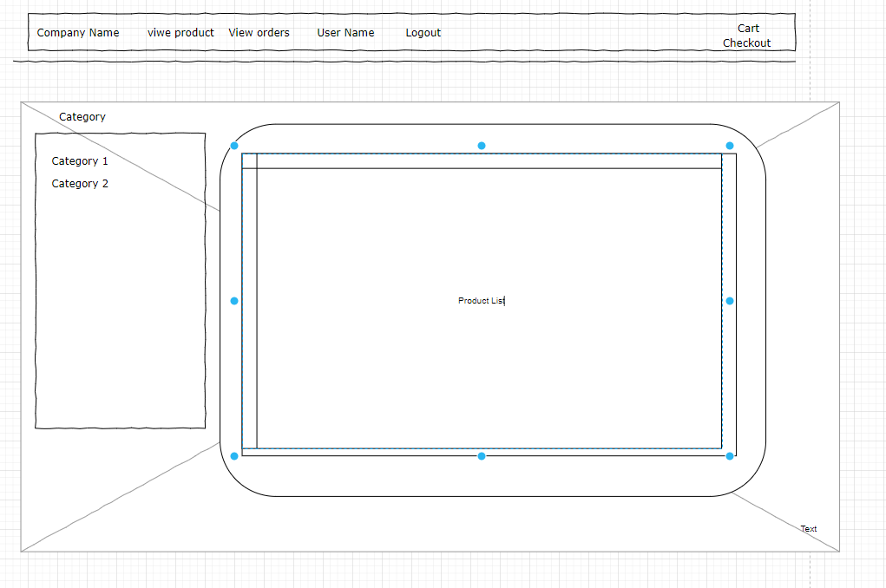

1. **User can view the product list and choose the category as filter after clicking on the “view Product”**
2. **User can add the product to the cart from the product list**

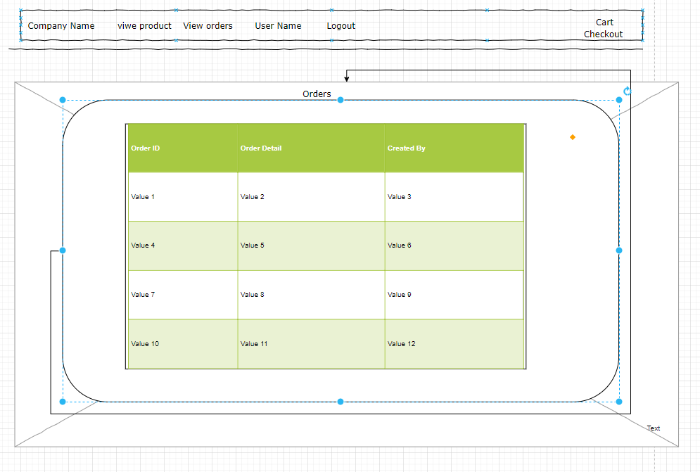

1. **User can view the Orders by clicking on the “view Orders”**
2. **User can see the order Id, order details and created Date from the order Table.**

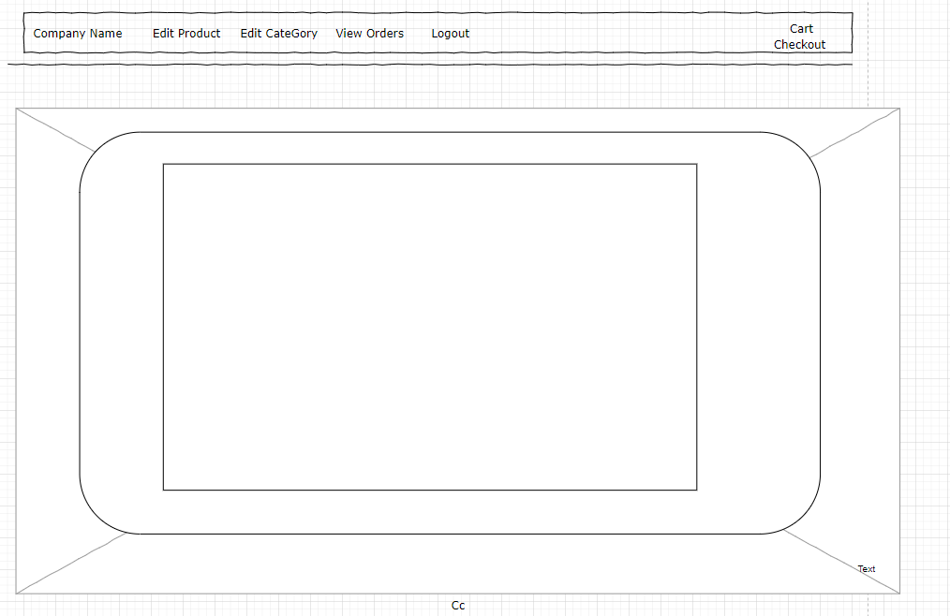

1. **Admin user can add,edit,remove product by clicking on the “Edit Product”**
2. **Admin user can add,edit,remove category by clicking on the “Edit Category”**
3. **Admin user can View all customers’ orders by clicking on the “View Orders”.**

**ER Diagram**

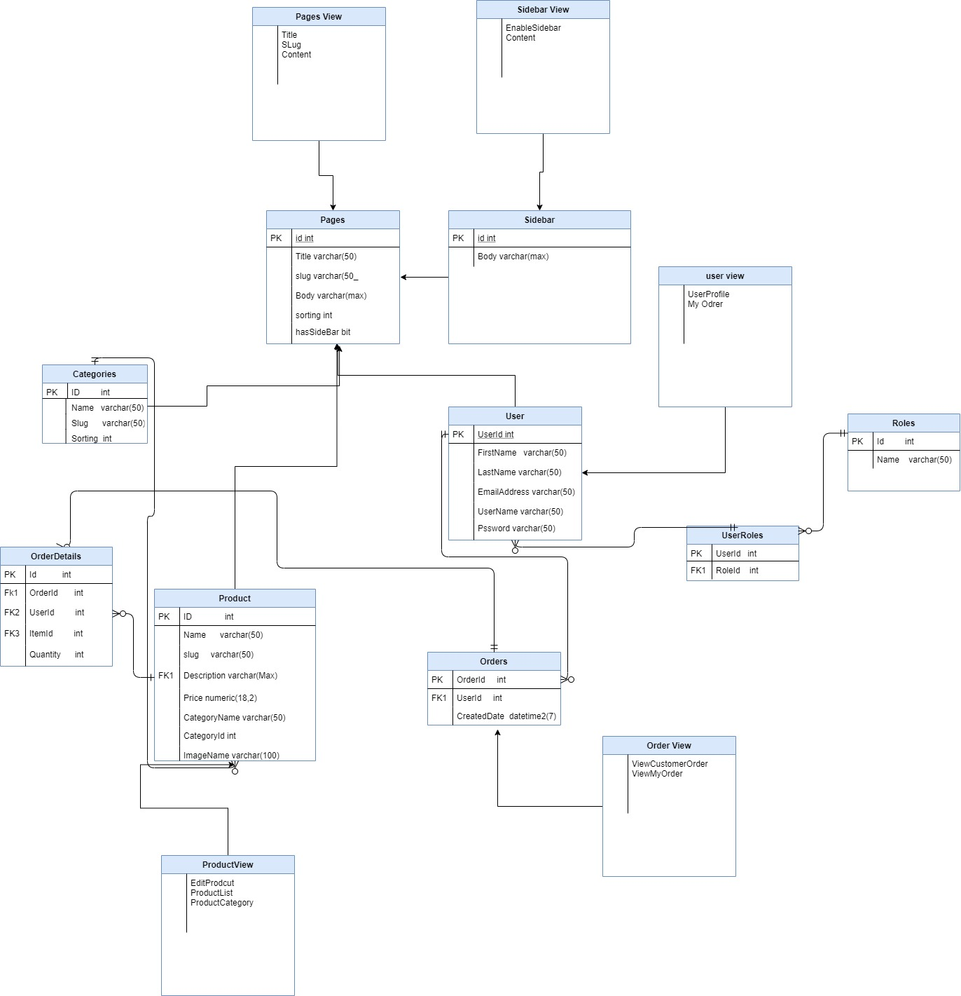

**UML Diagram**

**Admin edit product:**

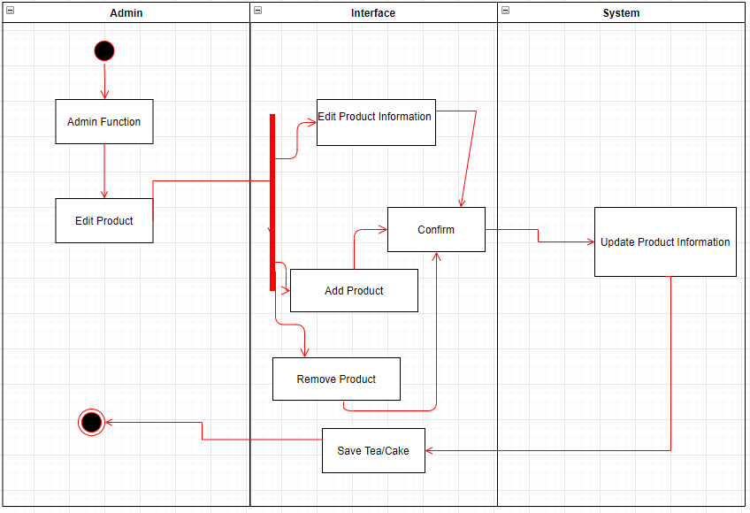

**Admin edit category:**

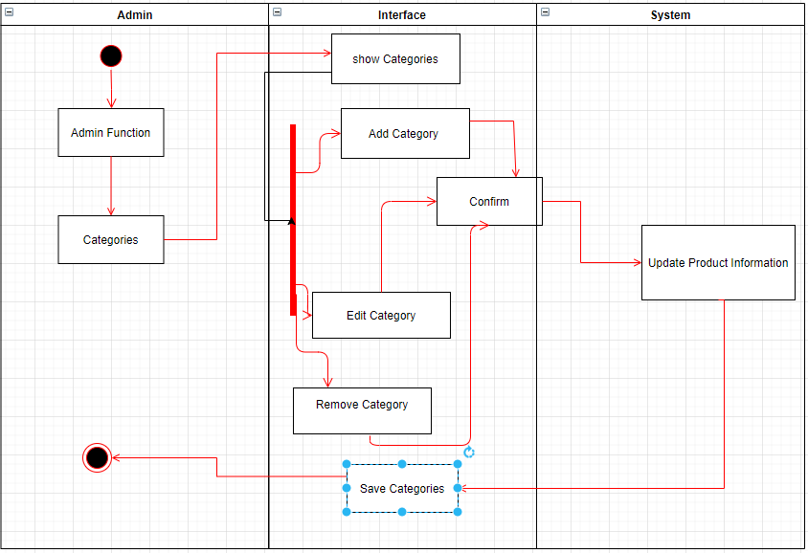

**Users view and place orders:**

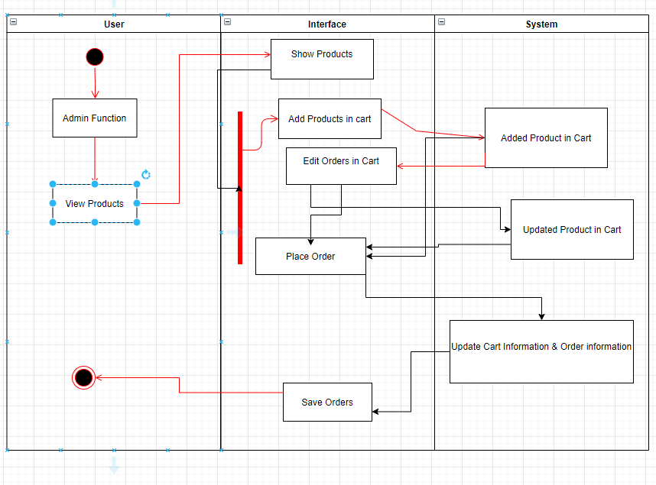

**Evidence on testing on more than one Browser:**

**Run in chrome:**

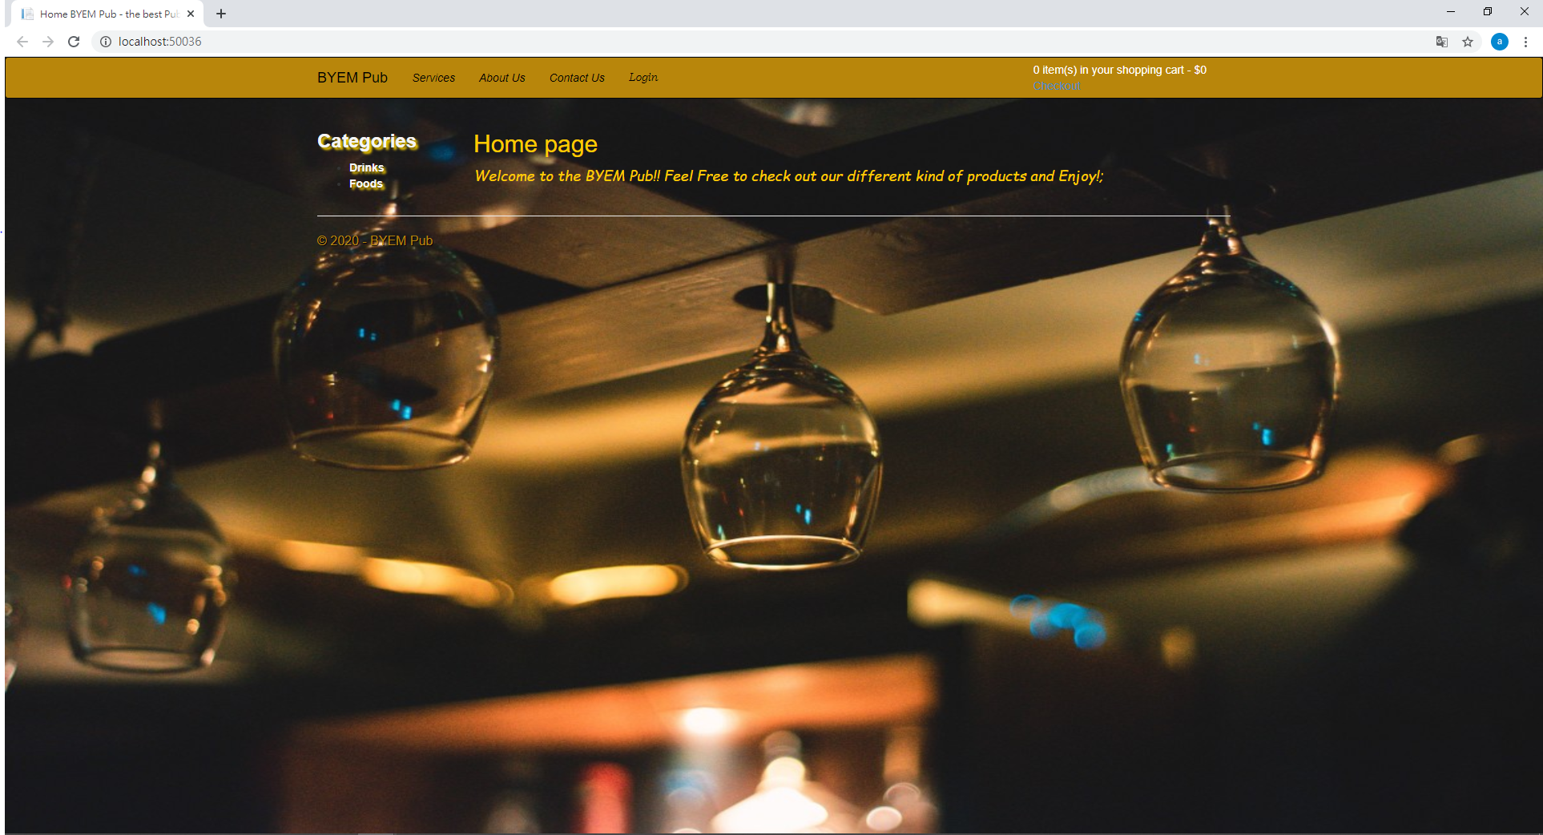

**Run in Avast secured browser:**

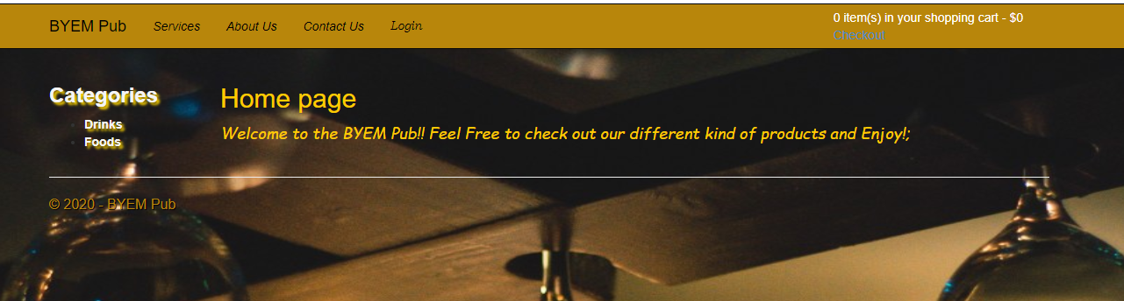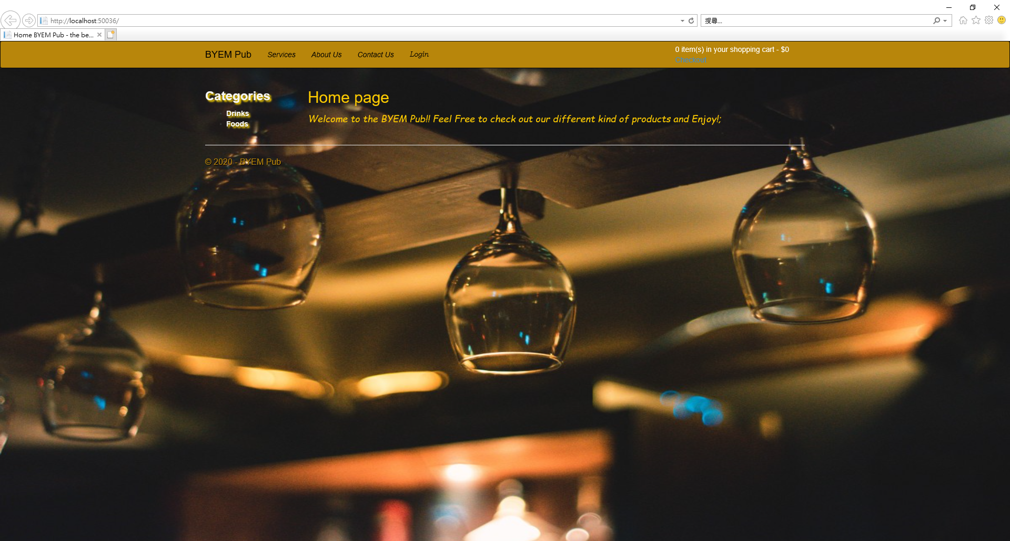

**Web Accessibility:**

**There’s navigation bar provided on the website which is more user friendly to use, and the Title Header and different function are considered to display by different colors and contrast level.**

**However, the website has not provided the different color theme and keyboard shortcut button to manipulate which is expected to change in order to make disabled persons to be able to use.**

**Images used in the Project:**

